KARTHIKEYA P  :pkarthik2391@gmail.com  : 09618808770 |  | 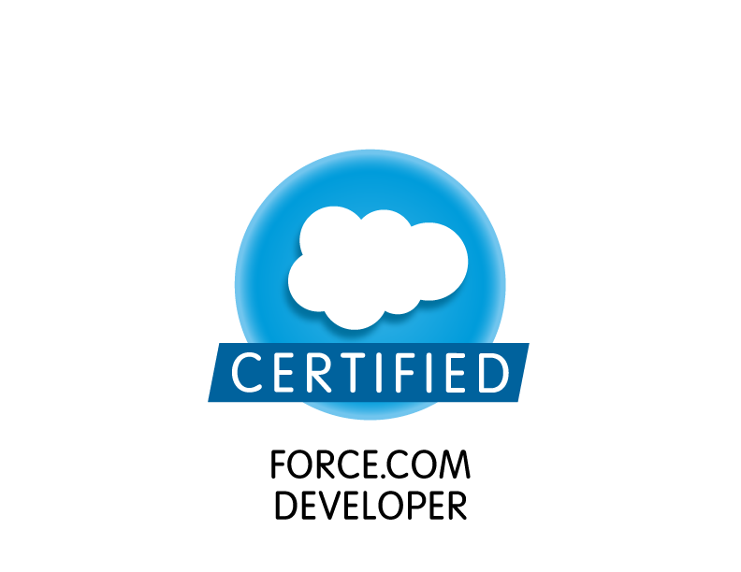  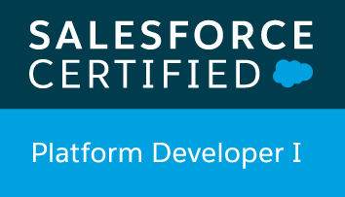

Career Overview

- Currently working as Senior Software Engineer at Tech Mahindra, India since December, 2015.
- 4 Years of experience with SalesForce Configuration, Customization, Integration – Rest and Soap API.
- Certified Salesforce.com Developer and Certified Platform Developer I.
- Extensive experience in creating Roles, Profiles, Page Layouts, Record Types,
Workflow Alerts, Reports, Dashboards, Approval Workflows
- Proficient in designing of Custom objects, Custom Settings, Custom fields,
profile based page layouts, Custom Tabs, Visual force Pages, Apex Classes, Controllers & Triggers, Custom Applications and Apex Web Services(REST,SOAP API's).
- Integrated salesforce with Docusign for secure signing of Documents – API Integration. Designed Data model and Designed functionality to handle all scenarios as per client requirement.
- Have hands on experience on Assignment rules, Entitlement Process, Milestones, knowledge Articles, Field sets, Communities and Email to Case.
- Proficient in using data migration tools like Eclipse IDE and SalesForce Apex Data Loader.
- Experience in languages and technologies such Java, HTML5, CSS3, JavaScript, XML, JSON and SOAP.
- Systematic Approach, quick adaptability to new technologies, ability to work with teams.

Technical Skills
CRM : Salesforce.com
SFDC Technologies : Apex, Visualforce (Page, Components & Controllers), Apex Data Loader
Languages : Java, XML, Java Script and C.
Web Technologies : XML, HTML, Java Script, JSON, CSS
Database : Oracle 9/10/11, SQL, DB2
Tools : Apache Tomcat Server, Eclipse IDE
Operating Systems : Windows 7/8, UNIX.

Education
- B.Tech (CSE) from GITAM College Of Engineering, Visakhapatnam, with an aggregate of 80.5%.
- 12th class from Intermediate board of Andhra Pradesh, with an aggregate of 93.9%.
- 10th class from Board of Secondary Education, with an aggregate of 89.5%.

Career Profile
Project-1:
Company | Tech Mahindra
Project | Citi Commercial Bank – CCB CRM
Customer | CITI
Period | November 2015 to till date
Role | Developer (Team Technical Lead).
Description | CITI - CCB: Citi Commercial Bank is part of CITI US project which stores the account information of the CITI US clients. CCB project provides sales and Service application which holds opportunities, products, assets of the client accounts. CCB project integrates with CITI Risk and AMC.
Technical Skills | Apex, Visualforce, Triggers, test classes, Web Services and reports. SalesForce functionality like workflows, approval process, custom settings, SalesForce Administration, Application customization. Familiar with groups, chatter, feeds and also worked on data loader and import wizard.
Responsibilities | - Developed Apex Classes, Controller Classes, extensions, Visual force pages and Apex Triggers for various functional needs in the application.  - Worked on Field Sets to render a set of fields dynamically based on a custom pick list field.  - Designed and Implemented Email to Case, Knowledge articles and milestones functionality.  - Worked on setting up of assignment rules, so that the cases will be assigned to specific queues based on a particular criteria.  - Worked on Rest integration with Docusign using CITI third party application - esign as middleware. Worked on two way authentication.  - Worked on SOAP integration as part of Docusign and Citi risk integration projects. Consuming WSDL from other applications  - Developed customer login Communities specific to rising of cases with respect to any issues.  - Implemented lightning based components in community – Custom Search functionality and in visual force pages –Live Tracking bar for the Credit application based on the status field.  - Supporting the project, fixing bugs (if any) and implementing all future possible enhancements.  - Received appreciations from client and manager for the dedicative effort on the Project.
Project Location | Hyderabad, INDIA

Project-2:
Company | Tata Consultancy Services
Project | BANK OF AMERICA – BOA-GWIM PACE
Customer | US TRUST- PACE
Period | September 2012 – October 2015
Role | Developer (Team member).
Description | Bank of America: BOA is one of the leading banks in the United States provides financial products, services, ideas and solutions to customers and clients in over 48 states. The bank has four main business segments, viz. Consumer Banking, Commercial Banking, Global Corporate and Investment Banking and Asset Management.  GWIM CFP: Global Wealth Investment management is built on SalesForce CRM Platform. This SFDC development project is handled by TCS for BOA-GWIM Client. This project is part of Legacy modernisation where PACE verticals such as SMAC are converting to use recent technologies such as Java and Salesforce.
Technical Skills | Apex, Visual force, Triggers, test classes, Web Services and reports. SalesForce functionality like workflows, approval process, custom settings, SalesForce Administration, Application customization.
Responsibilities | - Developing a design document with proposed implementation plans.  - Develop and Configure the UI screens according to the requirements document.  - Developing visual force pages, apex classes and triggers that implement the functionality of displaying the data to the users.  - Worked with various salesforce.com objects like Accounts, Contacts, Leads, Opportunities, Cases, Reports, and Dashboards.  - Opportunity Redesign: Developing apex classes that allow both mass update of opportunities and single opportunity updates.  - Developed batch apex classes for performing DML on set of client records.  - Worked on Batch apex and schedule apex classes.  - Supporting the project, fixing bugs (if any) and implementing all future possible enhancements.  - Handle Errors using Exception handling for ease of debugging and displaying error messages in application.
Project Location | Hyderabad, INDIA

Personal Information
Name : Karthikeya Piduru
Date of birth : 23-06-1991
Marital status : Single
Nationality : India
Passport : Available
Languages Known : English, Telugu, and Hindi.

